Project Title:
The Secret Life of Transistors
Group Members:
WCW40 | LS2878 |WPFC20 | LCS78 | JRS222 | FK486
Aims:
The high-level goals of this project are as follows:
- Understand the physics and structure of BJT and MOSFET transistors
- Understand the characteristics and operation of these transistors
- Be able to create logic gate circuits using the transistors
- Build a functional half-adder by combining logic gates made with transistors.
The overall purposes of this project are as follows:
- Construct a full adder, by combining the half-adder with other groups. If successful, combine full adders to make a 4-bit adder.
- Create and record a presentation on the fundamentals of BJTs and MOSFETs aimed at a non-technical audience.
Scope:
- To create a research document on semiconductor fundamentals, PN Junctions, NPN vs PNP Transistors, and MOSFETs
- To develop research in depth enough such that it can fill 5 slides of a 3-minute presentation
- To build a functional half adder using one type of transistor
- To use our half adder to complete a full adder and 4-bit adder with the help of other group's half adders
- The project must be completed by 06/11/2026 at 5pm.
- The resources available are the circuit components provided by the lab, such as the wire kits and various measurement apparatus.

SMART Objectives: - Specific Measurable Achievable Relevant Timely
 | SMART Objectives | Work Package(s)
O1 | Establish a team charter, including key roles, team objectives and corresponding tasks with deadlines, and norms in working environment by EOD 02/11/2026 | WP1
O2 | Ensure project documentation is complete, confirmed and accessible between team members, by 05/11/2026, 11:04am for the Audit test, where a random document must be located in under 30 seconds. | WP1  WP2
O3 | Conduct initial research on BJTs and MOSFET operating principles, and their input and/or output characteristics, complete by 03/11/2026, 12:15pm. | WP3
O4 | Construct functional circuits to test the relevant characteristics of BJTs and MOSFETs, compiling results as plots into a single document by EOD 03/11/2026 | WP4
O5 | Construct a functional half-adder, ensure its compatibility to make a full-adder circuit and verify their operation against the truth table. Complete by EOD 05/11/2026 | WP5
O6 | Integrate the circuit compatibility by creating two chained full adders by 06/11/2026, 10:15 am. Having collaborated with another group to create the full adder, collaborate with another group pair. | WP5
O7 | Create, record and upload an individual presentation explaining the fundamentals of transistors in three minutes, by 12pm on 06/11/2026 | WP6

Work Packages:
WP1 – Project Management
Aim: Establish the team structure, allocate responsibilities, plan the schedule and manage project progress.
Tasks:
- Establish team charter: agree on the team’s purpose, expectations and working arrangements
- Delegate tasks:
- Create a skills matrix to identify the strengths and weaknesses of group members
- Distribute tasks equally, using the skills matrix as guidance
- Create a Gantt chart (using the work packages and objectives):
- Determine the dependencies of each task to establish their order
- Communicate with team members to estimate the duration of each task
- Identify the critical path, and any slack time. Optimise resource allocation and parallelise tasks accordingly
Deliverables:
- D1) Creation of a team charter that team members adhere to
- D2) Completion of tasks by the correct people according to skill matrix
- D3) Creation of a Gantt chart that is closely followed throughout the project
WP2 – Quality Management System
Aim: Perform well in the QMS audit
Tasks:
- Create a folder tree according to the ISO 9001 QMS
  - Quality Documents
    - Quality manual
    - Procedure
    - Forms
  - Quality control
  - Engineering
  - Operations
  - Purchasing
  - Sales/Customer service
  - Human Resources
  - Documents gallery
- Create a document that explains the naming of all files. It should capture:
  - Version control
  - Easy to find documents
  - Naming convention
- An excel spreadsheet of all the files in the QMS and their location placed in the “documents gallery” folder of the QMS
- Traceability matrix which captures the Design and Development of the product.
Deliverables:
D1) A functional QMS file hierarchy
D2) Document outlining file naming structure
D3) File Location Spreadsheet
D4) D&D Matrix

WP3 – Transistor Research
Aim: To gain a solid understanding of transistor physics and structure through background research.
Tasks:
- Semiconductor research
  - Why are semiconductors more useful than a simple conductor?
  - How can the conductivity of a semiconductor be deliberately changed?
  - How does doping a semiconductor affect its charge carriers?
- PN Junction research
  - What materials might be used for the P and N-type regions?
  - Why are depletion regions found at the interface of PN junctions?
  - How do PN junctions behave under forward and reverse bias? Why is this helpful for transistor operation?
- NPN vs PNP transistors
  - What are the different use cases for NPN and PNP transistors?
  - How do the doping concentrations and physics dimensions of each region differ and why?
  - How does the physical structure of a BJT affect how it operates?
- MOSFET research
  - What important device characteristics are used to classify the performance of a MOSFET? Why are they important?
  - What advantages and disadvantages do MOSFETs have over BJTs?
  - How does a MOSFET utilise an electric field to control current?
Deliverables:
- D1) Research Document containing 4 sections: Semiconductor, PN Junctions, NPN vs PNP, and MOSFETs
WP4 – Transistor Investigation
Aim: To determine crucial characteristics of BJTs and MOSFETs.
Tasks:
- Study BJT Input Characteristics
  - Create this circuit:
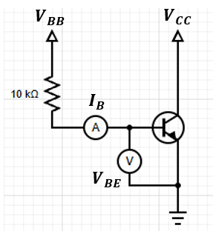
[1]
  - Set $V_{CC}$ = 2.5V
  - Adjust $V_{BB}$ from 1V to 15V, measuring $V_{BE}$ and $I_{B}$ at each voltage
  - Repeat this for 2 more $V_{CC}$ Voltages
  - Plot $I_{B}$ vs $V_{BE}$
- Study BJT Output Characteristics
  - Create this circuit:
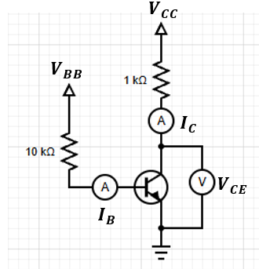
[1]
  - Use a value of $V_{BB}$ that gives $I_{B }≈10 μA$
  - Adjust $V_{CC}$ such that $V_{CE}$ has a range of values from 0.1V to 5V (Have a higher density of points for $V_{CE}$ < 1V to see saturation)
    - For each voltage, measure $I_{C}$
  - Repeat for 2 more values of $I_{B}$
  - Plot $I_{C}$ vs $V_{CE}$
- MOSFET Output Characteristics
  - Create this circuit:
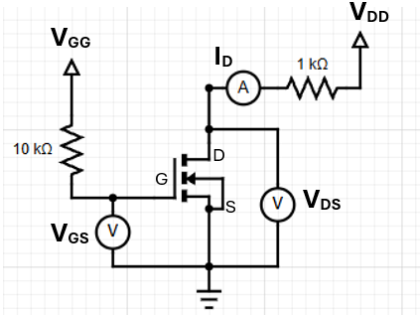
[1]
  - To measure drain characteristics:
    - Keep $V_{GS}$ constant at 4V by varying $V_{GG}$
    - Vary $V_{DS}$ by 0.2V, measuring $I_{D}$ until the current becomes constant
    - Once constant, vary $V_{DS}$ by 1V up until 15V
    - Repeat for two more $V_{GS}$ Voltages
    - Plot $I_{D}$ against $V_{DS}$
  - To measure transfer characteristics:
    - Keep $V_{DS}$ constant at 4V by using the drain supply $V_{DD}$
    - Vary $V_{GS}$ by 0.2V, measuring $I_{D}$ until the current becomes constant
    - Once constant, vary $V_{GS}$ by 1V up until 15V
    - Repeat for two more $V_{DS}$ Voltages
    - Plot $I_{D}$ against $V_{GS}$, so the gradient gives transconductance. Maximum will occur at the steepest gradient.
Deliverables:
- D1) BJT Input Characteristics $I_{B}$ vs $V_{BE}$ Plot
- D2) BJT Output Characteristics $I_{C}$ vs $V_{CE}$ Plot
- D3) MOSFET Drain Characteristics $I_{D}$ against $V_{DS}$ Plot
- D4) MOSFET Transfer Characteristics $I_{D}$ against $V_{GS}$ Plot
- D5) MOSFET maximum transconductance
WP5 – Logic Circuits
Aim: To understand the role of transistors in logic and build functioning logic circuits.
Tasks:
- Build individual logic circuits and test their functionality for each combination of inputs e.g.
NOT:
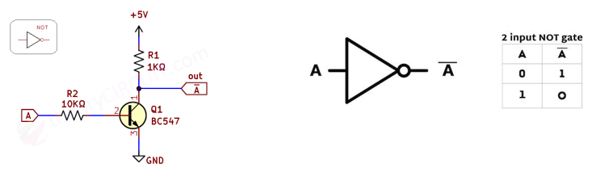
[2]
- Combine these logic gates to create a half adder and test its functionality for each combination of inputs
- Combine the half adder with another groups to create a full adder and test it.
- Combine the full adder with another group pairs to create two chained full adders, test against a truth table.
Deliverables:
- D1) Truth tables of the experimental logic gates: NOT, AND, OR, XOR are correct.
- D2) Truth table of experimental half adder is correct.
- D3) Truth table of experimental full adder is correct.
- D4) Truth table of experimental 4-bit adder is correct.
WP6 – Project Presentation
Aim: Individually create and successfully deliver a three-minute presentation on transistors.
Tasks:
- Create a slideshow no more than 5 slides long to present an overview of a transistor structure, characteristics and application to a non-technical audience.
  - Use charts, graphs, or tables to present data in a clear, visually appealing way. Ensure data elements are labelled to make it easy to understand
  - Creating Diagrams and Flowcharts: use diagrams to explain complex ideas, especially if steps are involved.
  - Readability: use consistent font sizes and styles and avoid overloading slides with text.
- Record yourself presenting this slideshow. You should focus on:
  - Speaking clearly, at a well-paced speed, with an appropriate volume and confidence
  - Avoid filler words and sounding unsure
Deliverables:
D1) Slideshow on transistors that can be understood by a non-technical audience available on Mahara.
D2) Recording of a confidently delivered presentation on transistors available on Mahara.
Milestones:
Work Package | Description | Target date and time  (WB: 2/11)
WP1 | Team charter, skills matrix and Gantt chart complete | EOD 02/11/2026
WP2 | Audit complete | 11:15am 05/11/2026
WP3 | All four sections of the research document completed | 1pm 04/11/2026
WP4 | All plots created and maximum transconductance | EOD 03/11/2026
WP5 | All logic gates' circuits verified against their truth tables. | EOD 04/11/2026
WP6 | Transistor presentation submitted | 1pm 06/11/2026

References
[1] University of Bath, n.d. Year 2 Project Weeks: PW1 Transistors, Task 2 [online lab script; Bath login required]. Available from: https://github.bath.ac.uk/pages/EEE-Teaching/Published_Y2_Project_Weeks/PW1_Transistors/Task2.html [Accessed 5 November 2026].
[2] University of Bath, n.d. Year 2 Project Weeks: PW1 Transistors, Task 3 [online lab script; Bath login required]. Available from: https://github.bath.ac.uk/pages/EEE-Teaching/Published_Y2_Project_Weeks/PW1_Transistors/Task2.html [Accessed 5 November 2026].

